The following sections must be included in your project report-
- Title Page
- Table of Contents
- Introduction
The "Village to City View" is a computer graphics project developed using OpenGL with GLUT that visually represents the journey from a peaceful rural village to a busy urban city. The project is designed and implemented by a team of five members, showcasing teamwork, creativity, and technical skill in graphics programming.

In this project, a train acts as the primary moving element that travels through various scenes—from a natural village with green fields, rivers, small huts, and trees, gradually transitioning into a modern city with high-rise buildings, roads, traffic, and city lights. This smooth transition emphasizes the contrast between rural simplicity and urban development.

We have used OpenGL with GLUT to build realistic 2D scenes, implement animations (such as the moving train, clouds, sun/moon), and simulate environmental changes (like day-night effects). The goal of this project is to present the beauty and evolution of landscapes through animation while enhancing our understanding of computer graphics concepts.

- Project Graph – This part will you look at the project design. Also it will guide with coordinates with which you will be working.

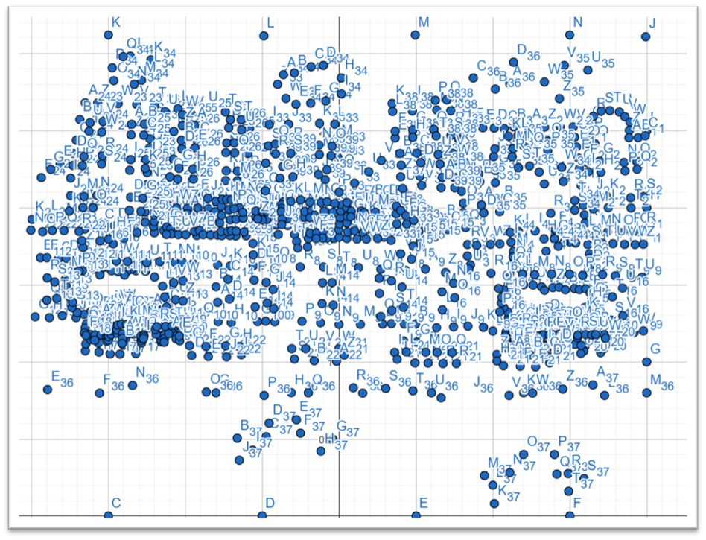
Fig- Screen 4
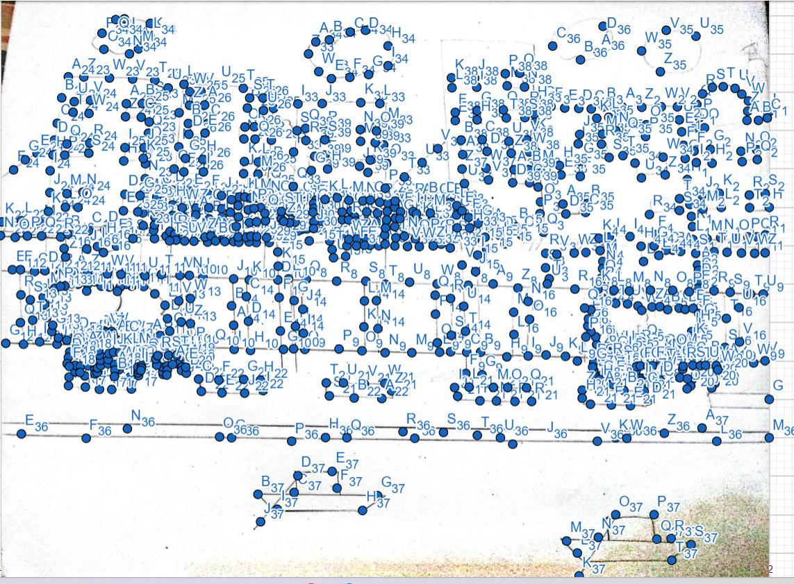

Fig: Screen 4
- List of objects assigning an object ID – Make a list of the objects that will be included in your project. MUST follow the following listing pattern. ID:22-49676-3
SL# | Object ID | Object Name
1 | Object_1 | Sky
2 | Object_2 | Sun
3 | Object_3 | Clouds
4 | Object_3 | Lighting
5 | Object_4 | Building
6 | Object_6 | Hospital
7 | Object_5 | Mosque
8 | Object_6 | Church
9 | Object_7 | Rail Line
10 | Object_8 | Train
11 | Obejct_9 | Lamppost
12 | Object_10 | Tree
13 | Object_11 | Road
14 | Object_12 | Car
15 | Object_13 | Grass
16 | Object_14 | River
17 | Object_15 | Boat
18 | Object_18 | Walking Zone
19 | Object_19 | Seating zone
20 | Object_20 | Rainbow
21 | Object_21 | Tracks
- List of Functions To Represent Objects- Each object must be represented by a function. MUST follow the following listing patternID:22-49676-3
SL# | Object Name | Function Name
1 | Sky | Void_sky
2 | Sun | Void_sun
3 | Clouds | Void_Clouds
4 | Building | Void_Building
5 | Hospital | Void_Hospital
6 | Mosque | Void_Mosque
7 | Church | Void_Church
8 | Rail Line | Void_Rail_Line
9 | Train | Void_Train
10 | Lamppost | Void_Lamppost
11 | Tree | Void_Tree
12 | Road | Void_Road
13 | Tree | Void_
14 | Grass | Void_Grass
15 | River | Void_River
16 | Boat | Void_Boat
17 | Walking Zone | Void_Walking_Zone
18 | Seating zone | Void_SeatingZones
19 | Tracks | Void_ Tracks
- List of Animation Functions with ID – These should be functions that are used to add animations like- object movement, mouse, and keyboard interaction, change of scenarios and so on. MUST follow the following listing patternID:22-49676-3
SL# | Animation Function ID | Animation Function | Object/Scene
1 | M(Keyboard) | Sun | Moving One side
2 | D(Keyboard) | Sun | Moving another side
3 | N(Keyboard) | Sun | Moving One side
4 | All time Moving | Cludes | Plane Moving
5 | R (Keyboard) | Rainbow | When Rain On For 3s
6 | L(Keyboard) | Lighting | When Rain
7 | Mouse Right | Rain | Start
8 | Mouse left | Rain | Stop
9 | - (Keyboard) | Train | Speed Down
10 | + (KeyBoard) | Train | Speed Fast
11 | N | Lamppost | Light On
12 | M/D | Lamppost | Light Off
13 | -(KeyBoard) | Boat | Speed Down
14 | + (keyboard) | Boat | Speed fast
15 | N | Building Light | On in Night
16 | M/D | Building Light | Off This Time
- Contribution – This part will list the contribution of each member. MUST follow the following listing pattern-
Member Name | Implemented Functions | Implemented  Animation Functions | Percentage of Contribution
 |  |  | Full
 |  |  | Full
 |  |  | Full
Md Thamedul Islam Shadin |  |  | Full
 |  |  | Full
- Conclusion

Add the IDs as a comment at the start of each function. This will help you to search the functions easily.

